mhabibPrinting MyMath homework pages.

Log into connected  https://connected.mcgraw-hill.com/lausd | 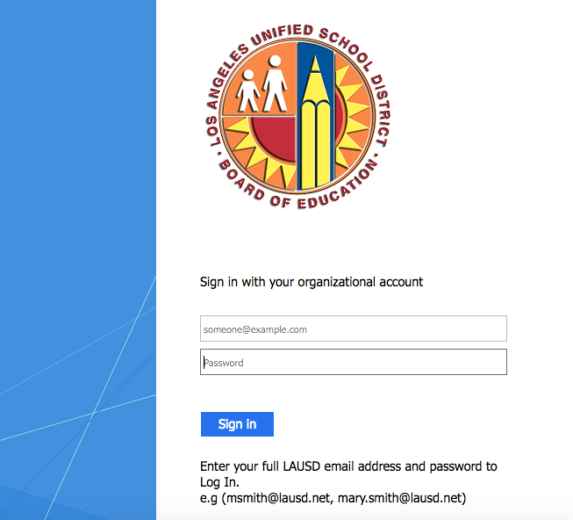
Click on the MyMath book | 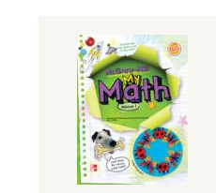
Choose the chapter and lesson we are on. Click on the lesson. | 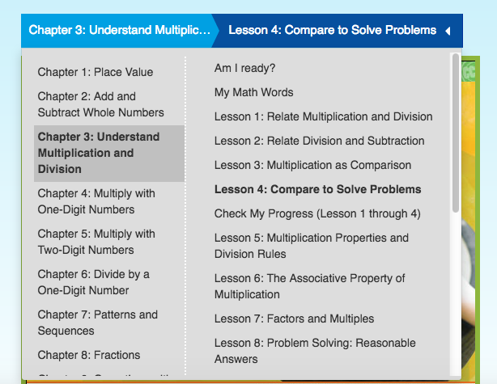
Then click on the e-book link.
To print, click on the green icon with the paper picture. | 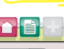
Click on the homework sheet. | 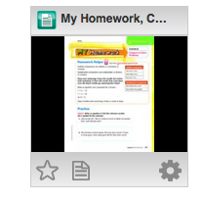
TO PRINT
Click on the printer icon.

