Questions Answers

Electrical energy can be converted into which forms of energy? | Light energy, heat energy, and motion energy.
Look at the pictures. Which of these objects can convert energy into heat energy?  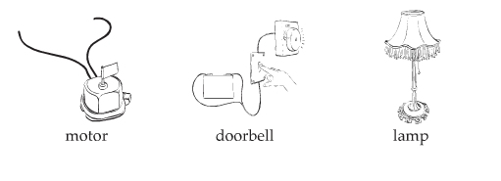 | Lamp
An iron converts electrical energy into what kind of energy?  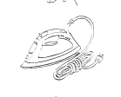 | Heat energy
If you rub a wool cloth against two balloons and let them go, what will happen? | 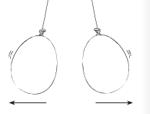  The balloons with attract to each other.
Look at the picture. What is needed for the circuit to work?  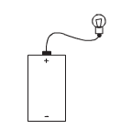 | You need a wire attached to the negative part of the D-cell and the side of the light bulb.
What do you need to make an electromagnet? | A long wire, D-cell, a metal rivet.

What do you think will happen if you let go of these two magnets? | The magnets will repel away from each other.
What do you think will happen if you let go of these two magnets? | The magnets will attract towards each other.
Three magnets were put together. Which magnet is placed incorrectly? Explain. | 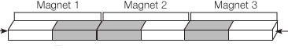
How can you make an electromagnet stronger?  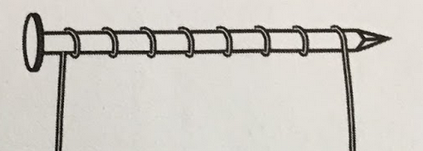 | Add more coils and add another D-cell.
What would cause a compass’s needle change directions? | A magnet.
A compass’ needle always points North. Why is this magnet not pointing North?  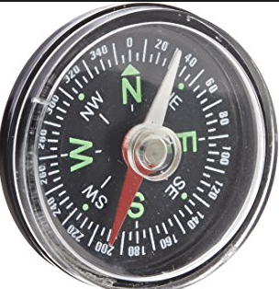  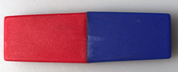 | The magnet is attracting the compass’ needle, which is why it isn’t pointing North.

