**Fraction Review**

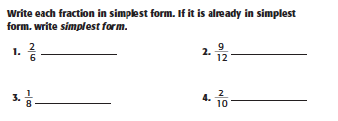

_________________________________________________________________________________________________

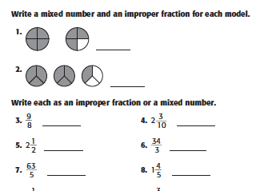

Add. Simplify if possible.

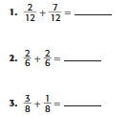 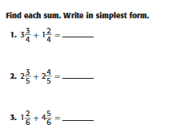

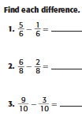

____________________________________________________________________________________________________________

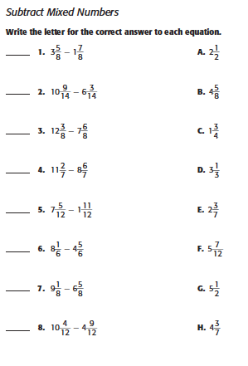

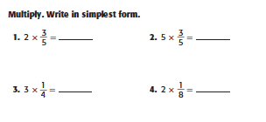

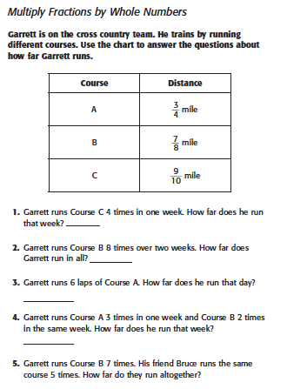

**Solve each Word problem by drawing a picture and/or writing an equation.**

