How are canyons like the Grand Canyons formed, or created? | They are formed by rivers and wind eroding the land after millions of years.
What is weathering? | Weathering is when Earth materials like rocks are broken or break.
What name 4 causes of weathering? | Wind  Water  Ice  Earthquakes  Volcanoes  Tree roots  Animals  Humans
How do sedimentary rocks change into metamorphic rocks? | Through heat and pressure
How do igneous rocks change into sedimentary rocks? | Through weathering and erosion
How do metamorphic rocks change into igneous rocks? | Through melting

Which of these examples happens the fastest?  - Glaciers moving  - Rocks being weathered by water  - Volcanoes erupting | Volcanic eruption
What most likely caused this damage? 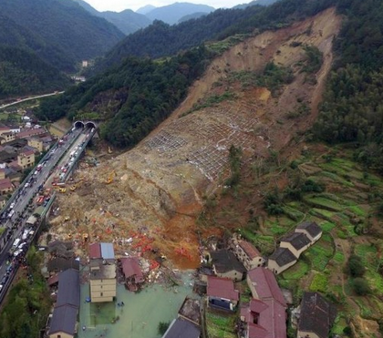 | landslide
What caused this rock to break?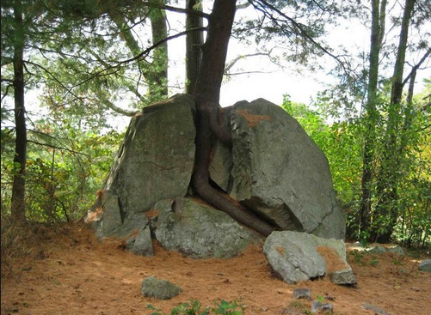 | The tree root growing in the rock caused the rock to break.
Use the mineral chart to help you identify the mineral.  Its color is blackish. It is a soft mineral. Its streak is black. | Graphite
Martha found a mineral. She wants to test the minerals hardness. List the steps she should take in order.  - Use the results on the mineral chart.  - Scratch the mineral with her fingernail.  - Scratch the mineral with an aluminum nail.  - Gather her materials. | First, gather her materials.  Then scratch the mineral with her fingernail.  Next, scratch the mineral with an aluminum nail.  Finally, use the results on the mineral chart.
This mineral’s hardness is 3. Its color is gray. What’s the name of the mineral?  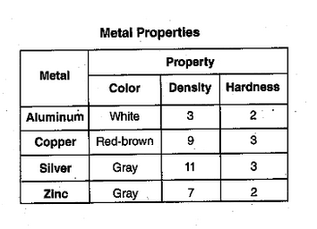 | Silver
Andy found a rock. It had a fossil of a fish and many layers. What type of rock is it?  Igneous, sedimentary, or metamorphic? | Sedimentary
Eddy found this rock by the river. How did it get so smooth?  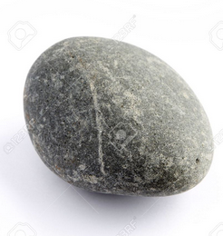 | After thousands and millions of years or weathering and erosion, the rock became smooth.  Or  The rocks banged against each others in a river during erosion.
Which process erodes mountains the slowest?  Lava, glaciers, mudslides, rivers | Glaciers
Jane found a mineral. Her fingernail scratched it. Could an aluminum nail scratch it? Why or why not? | An aluminum nail can scratch it because it is soft.
Where does the sand on the beach come from? | It came from the mountains and rivers to the shore eroded it.
What is erosion? | Erosion is when rocks are carried by water or wind.
What is deposition? | Deposition is when rocks and Earth’s materials are deposited or stopped on the land.
How was this delta formed?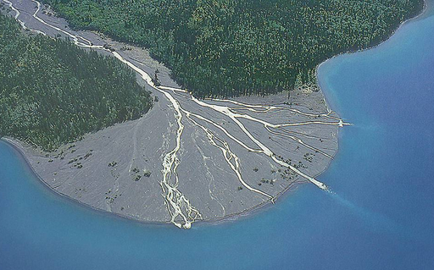 | The river deposited the sand and rocks.
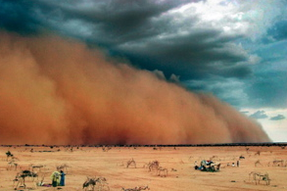  What is eroding the sand? | Wind
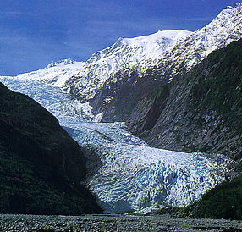  What is eroding this mountain? | A glacier
Use the mineral chart to help you identify the mineral.  The color of the mineral is green. It has a hardness of 4 and the streak color is white. | Fluorite
What is weathering this rock?  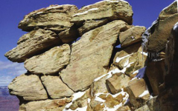 | Water and ice
What will this landform look like in the next hundred million years? 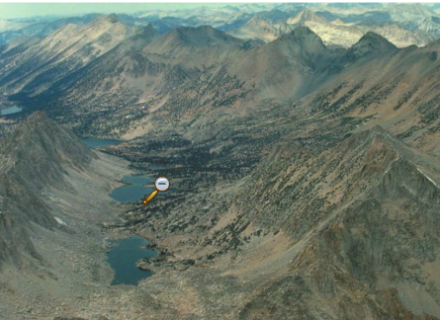 | It will be flatter, wider, less mountains,
What are the three types of weathering? | Physical/ mechanical weathering  Chemical weathering  Biological weathering
When wind and water carry rocks away, it is called _________. | Erosion
When rocks are broken into smaller pieces, this is called__________. | Weathering
When rocks get deposited into deltas or beaches, this is called __________. | Deposition
When rocks get put under a lot of heat and pressure, they turn into what type of rock?  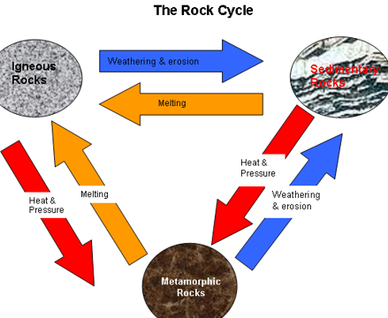 | Metamorphic rock
Wendy found a mineral. She was not able to scratch it with her fingernail, an aluminum nail, or a steel paper. Is this mineral.  What’s the best way to describe the mineral?  It is softer than a fingernail.  Or  It is harder than a steel paper clip. | It is harder than a steel paper clip.
If a volcano erupts and the magma cools, what type of rock will be formed?  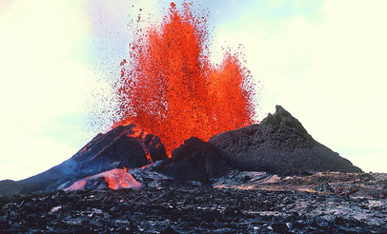 | Igneous rock
If rocks get weathered, and then they get cemented together, it will look like the rock shown. There are many layers or rocks. What type of rock is it?  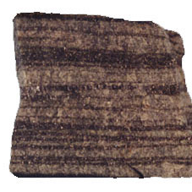 | Sedimentary rock
If a rock gets put under extreme heat and pressure, it can change into a ___________ rock. | Metamorphic rock

